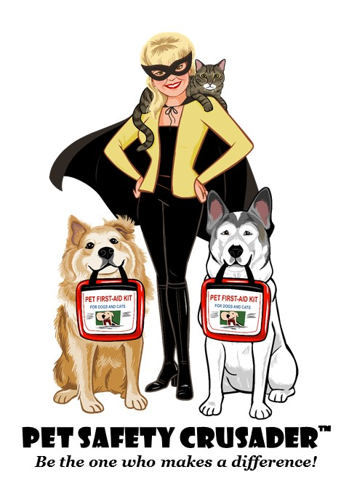

🐾 While you were away, I moved, secured, or relocated the following items to help keep your precious animal family safe:

Your pet’s safety is always my top priority, and if they can reach it, they can get into it.

[Sign, include contact info, and replace my logo above with yours]

